# 



Jeppe Dam-Hansen, Casper Gøtsche Olsen, Imad Ramez H Mostafa, Joakim Nielsen, Lierop Stijn v, Mannesse M, Martynas Saulytis, Shitiz Piplani

# High Level Design

## Introduction

This HLD is one of the parts of the Fontys project. It is the fifth area out of nine connecting to the switch EX4200. Its main design is using OSPF to determine the shortest path between itself and any neighbor router. All of the different OSPF areas are connected to a backbone router in OSPF area 0. The goal of this project is to be able to connect to other clients that are connected through different OSPF areas to the main OSPF area 0.

## Overview

Our topology is composed out of 2 networks which are both connected to the same virtual instance on different interfaces which are configures on a router on the EX4200 switch. Our two networks are both connected to virtual router 5 in OSPF area 5 0.

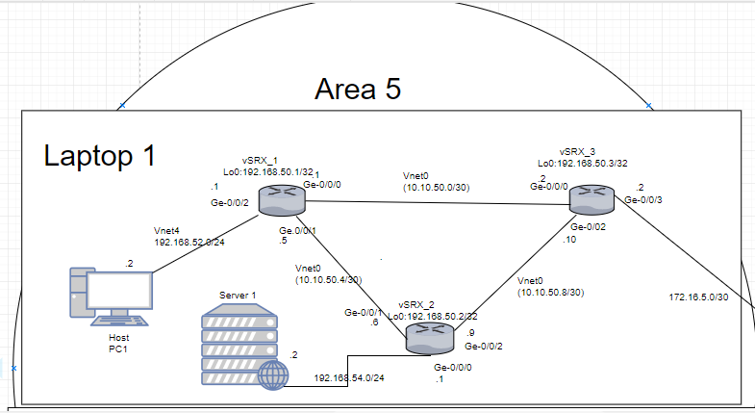

There are two PC’s connected to the network. “PC 1” is connected to “vSRX_1”, and acts as a simple user. “vSRX_1” has been setup with DHCP, which gives “PC 1” its IP address.  
“PC2” is connected to “vSRX_2”. In addition, “PC2” has a webserver set up which has a static IP address. “vSRX_3” is the router which connects Area 5 to the backbone router which connects to Area 0.

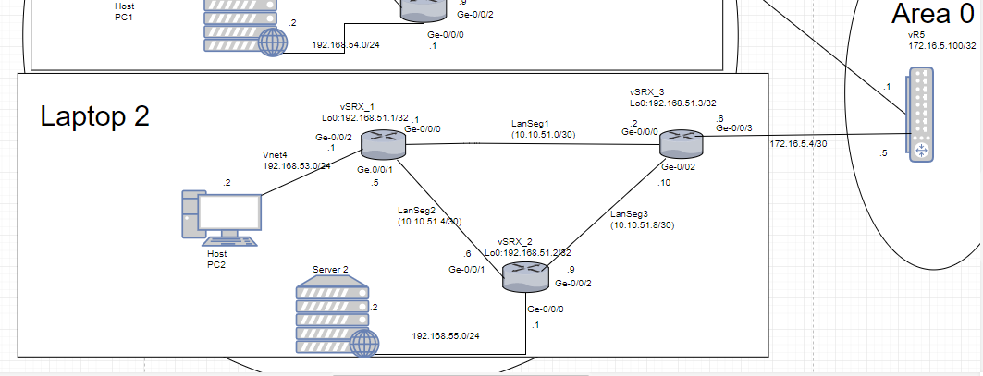

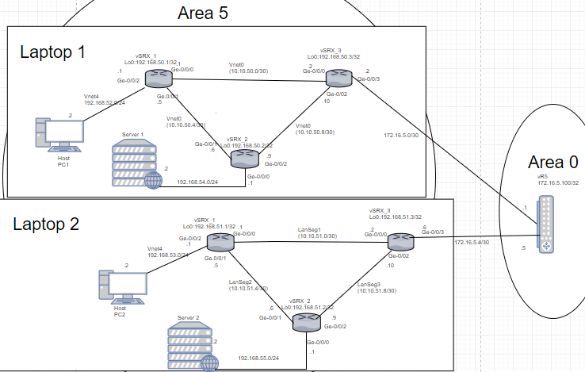

## Performance

The expected performance of this Fontys network is to be low latency, high availability, high band-with. It has close to none concurrent users. The expected traffic is close to zero because the potential amount of client users connected to it is approximately 16. The fifth area’s expected client amount is 4, which means there is a tremendous amount of room being unused.

## Security

The network we have set up does not really have any security set up. We have set up OSPF protocols in the security Trust-zone. Also we allowed inbound traffic to allow everything through in the Trust-zone as well.

## Hardware

Juniper Router srx

<https://www.juniper.net/us/en/products-services/security/srx-series/srx1500/>

Juniper Switch EX4200

<https://www.juniper.net/us/en/products-services/switching/ex-series/ex4200/>

## Protocols and standards

root@VSRX1# run show OSPF neighbor.

root@VSRX1# run show OSPF database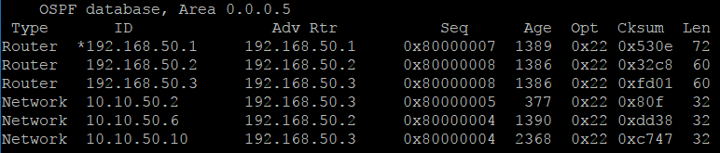

root@VSRX1# run show route terse

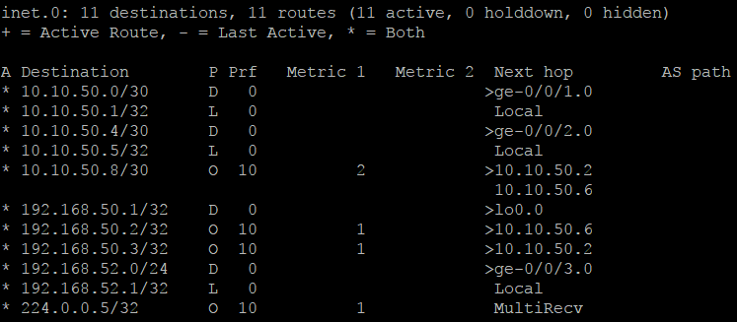

OSPF: OSPF is Open Shortest Path First and are setup on all three routers, which all are in Area 5. This means that all the routers have the same database of the other routers and the routes between them in the same area. Every 10 seconds a “hello” message is being sent from a router to its neighbours, and if it receives a reply the connection is preserved. If the message is not replied to in 10*4 seconds, the connection is dead, and the router alerts all other routers in the area that they need to update their database.

## IP layout Vlan layout

**LAPTOP 1**

1. Subnet: 192.168.52.0/24
   1. 192.168.52.1 🡪 VSRX1
2. Subnet: 10.10.50.0/30
   1. 10.10.50.1 🡪 VSRX1
   2. 10.10.50.2 🡪 VSRX3
3. Subnet: 10.10.50.4/30
   1. 10.10.50.5 🡪 VSRX1
   2. 10.10.50.6 🡪 VSRX2
4. Subnet: 10.10.50.8/30
   1. 10.10.50.9 🡪 VSRX2
   2. 10.10.50.10 🡪VSRX3
5. Subnet: 172.16.5.0/30
   1. 172.16.5.2 🡪 VSRX3
   2. 172.16.5.1 🡪 VR1 - AREA 0

**LAPTOP 2**

1. Subnet: 192.168.51.0/24
   1. 192.168.51.1 🡪 VSRX1
2. Subnet: 10.10.51.0/30
   1. 10.10.51.1 🡪 VSRX1
   2. 10.10.51.2 🡪 VSRX3
3. Subnet: 10.10.51.4/30
   1. 10.10.51.5 🡪 VSRX1
   2. 10.10.51.6 🡪 VSRX2
4. Subnet: 10.10.51.8/30
   1. 10.10.51.9 🡪 VSRX2
   2. 10.10.51.10 🡪VSRX3
5. Subnet: 172.16.5.4/30
   1. 172.16.5.6 🡪 VSRX3
   2. 172.16.5.5 🡪 VR1 - AREA 0

## Naming convention

The way we have setup our interfaces, is so that they routers always will face the same interface, as they are outputting from. So Ge-0/0/0 from vSRX_1 will face Ge-0/0/0 from vSRX_3. This way the diagram topology seemed more logical to us. We used subnetting to make the subnets between the routers, to not waste IP addresses and to make an easil y reproduceable network, so everyone in our group could setup the network correctly. The ones we used was 10.10.50.0/30, were each different subnet then were 4 higher, so 10.10.50.4/30 and 10.10.50.8/30.   
Then we mirrored the pattern for the second laptop, just with using 51 instead of 50, as on laptop 1. This made the 2 laptops topology nearly identical, which makes our troubleshooting much easier, since we were all basically working on the same network setup. Then for the 2 VPC on each network, we used 52 and 54 for Laptop 1 and on laptop 2 we used 53 and 55.

**LAPTOP 1**

Router 1: VSRX1:

VSRX1 Name: 192.168.50.1

Router 2: VSRX2:

VSRX2 Name: 192.168.50.2

Router 3: VSRX3:

VSRX3 Name: 192.168.50.3

**LABTOP 2**

Router 1: VSRX1:

VSRX1 Name: 192.168.51.1

Router 2: VSRX2:

VSRX2 Name: 192.168.51.2

Router 3: VSRX3:

## Pinging our webserver

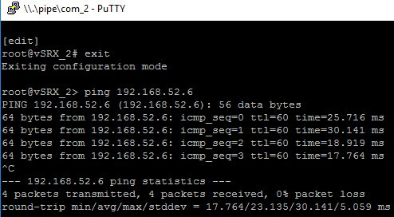

This was an attempt to ping the webserver on Laptop 1 (192.168.52.6) from the webserver on laptop 2 (192.168.55.2). This attempt was successful. However earlier attempts were unsuccessful, for a variety of reasons. One of these were that we had forgotten to setup OSPF on the webservers interface on vSRX_2, which resulted made the webserver unable to be found by OSPF, meaning that laptop 1 webserver didn’t recognize the webserver on laptop 2.

Date: 9/11-2017  
Tested by: Jeppe

## Pinging other webservers

root@vSRX_1> ping 10.10.2.242

PING 10.10.2.242 (10.10.2.242): 56 data bytes

64 bytes from 10.10.2.242: icmp_seq=0 ttl=60 time=22.820 ms

64 bytes from 10.10.2.242: icmp_seq=1 ttl=60 time=12.111 ms

64 bytes from 10.10.2.242: icmp_seq=2 ttl=60 time=18.105 ms

^C

--- 10.10.2.242 ping statistics ---

3 packets transmitted, 3 packets received, 0% packet loss

round-trip min/avg/max/stddev = 12.111/17.679/22.820/4.382 ms

root@vSRX_1> ping 10.10.3.14

PING 10.10.3.14 (10.10.3.14): 56 data bytes

64 bytes from 10.10.3.14: icmp_seq=0 ttl=59 time=23.434 ms

64 bytes from 10.10.3.14: icmp_seq=1 ttl=59 time=24.078 ms

64 bytes from 10.10.3.14: icmp_seq=2 ttl=59 time=18.357 ms

^C

--- 10.10.3.14 ping statistics ---

3 packets transmitted, 3 packets received, 0% packet loss

round-trip min/avg/max/stddev = 18.357/21.956/24.078/2.559 ms

root@vSRX_1> ping 172.16.4.2

PING 172.16.4.2 (172.16.4.2): 56 data bytes

64 bytes from 172.16.4.2: icmp_seq=0 ttl=59 time=15.610 ms

64 bytes from 172.16.4.2: icmp_seq=1 ttl=59 time=30.302 ms

64 bytes from 172.16.4.2: icmp_seq=2 ttl=59 time=18.400 ms

64 bytes from 172.16.4.2: icmp_seq=3 ttl=59 time=13.457 ms

^C

--- 172.16.4.2 ping statistics ---

4 packets transmitted, 4 packets received, 0% packet loss

round-trip min/avg/max/stddev = 13.457/19.442/30.302/6.510 ms

root@vSRX_1> ping 192.168.55.2

PING 192.168.55.2 (192.168.55.2): 56 data bytes

64 bytes from 192.168.55.2: icmp_seq=0 ttl=63 time=16.412 ms

64 bytes from 192.168.55.2: icmp_seq=1 ttl=63 time=12.690 ms

64 bytes from 192.168.55.2: icmp_seq=2 ttl=63 time=12.010 ms

64 bytes from 192.168.55.2: icmp_seq=3 ttl=63 time=7.047 ms

^C

--- 192.168.55.2 ping statistics ---

4 packets transmitted, 4 packets received, 0% packet loss

round-trip min/avg/max/stddev = 7.047/12.040/16.412/3.334 ms

root@vSRX_1> ping 192.168.64.69

PING 192.168.64.69 (192.168.64.69): 56 data bytes

64 bytes from 192.168.64.69: icmp_seq=0 ttl=59 time=26.133 ms

64 bytes from 192.168.64.69: icmp_seq=1 ttl=59 time=23.677 ms

64 bytes from 192.168.64.69: icmp_seq=2 ttl=59 time=23.875 ms

64 bytes from 192.168.64.69: icmp_seq=3 ttl=59 time=19.171 ms

^C

--- 192.168.64.69 ping statistics ---

4 packets transmitted, 4 packets received, 0% packet loss

round-trip min/avg/max/stddev = 19.171/23.214/26.133/2.526 ms

root@vSRX_1> ping 192.168.76.2

PING 192.168.76.2 (192.168.76.2): 56 data bytes

64 bytes from 192.168.76.2: icmp_seq=0 ttl=59 time=21.773 ms

64 bytes from 192.168.76.2: icmp_seq=1 ttl=59 time=24.901 ms

64 bytes from 192.168.76.2: icmp_seq=2 ttl=59 time=25.681 ms

64 bytes from 192.168.76.2: icmp_seq=3 ttl=59 time=19.588 ms

--- 192.168.76.2 ping statistics ---

4 packets transmitted, 4 packets received, 0% packet loss

round-trip min/avg/max/stddev = 19.588/22.986/25.681/2.447 ms

root@vSRX_1> ping 10.10.85.1

PING 10.10.85.1 (10.10.85.1): 56 data bytes

64 bytes from 10.10.85.1: icmp_seq=0 ttl=57 time=21.206 ms

64 bytes from 10.10.85.1: icmp_seq=1 ttl=57 time=19.283 ms

64 bytes from 10.10.85.1: icmp_seq=2 ttl=57 time=23.868 ms

64 bytes from 10.10.85.1: icmp_seq=3 ttl=57 time=17.762 ms

--- 10.10.85.1 ping statistics ---

4 packets transmitted, 4 packets received, 0% packet loss

round-trip min/avg/max/stddev = 17.762/20.530/23.868/2.281 ms

This is the logs of pinging all the other webserver in the order of the groups (1-8).  
This worked just as the other since every webserver was set up correctly

Date: 9/11-2017  
Tested by: Jeppe

## Proof of work

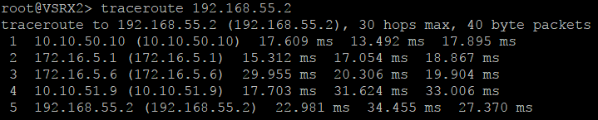

Here is a traceroute from VSRX2 (10.10.50.2) to 192.168.55.2, which is a host connected in the same Area, but on a different PC. For it to work, the packet must first enter the router that connects Area 5 and Area 0, on the switch. The IP Address 172.16.5.1 are the address on the virtual router on the switch. The packet then enters the connected PC’s routers (172.16.5.6 and 10.10.51.9), then the host (192.168.55.2).

# Low Level Design

